IE4-MC Lab Session #1: Preparation sheet
Surname, First Name | Group Team
1.Nikolay Stoitsov  2.  3. | 1 ◻ A B C D E F  2 ◻  3 ◻
This preparation sheet must be filled and uploaded to EMIL by every student before the lab session. Cooperation within the lab team (of 2-3 students) is possible (same solution). However, no cooperation across lab teams.

Question 1 (3 POINTS)
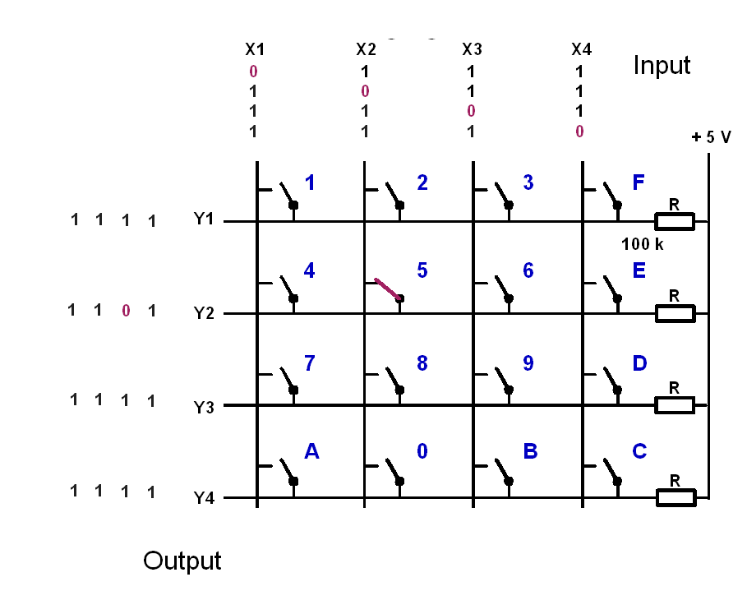
Let the input signals to the keyboard be (X1,X2,X3,X4)=(1,0,1,1). Give the output signals (Y1,Y2,Y3,Y4), if the following keys are pressed:
key | y1 | y2 | y3 | y4
1 pressed | 1 | 1 | 1 | 1
5 pressed | 1 | 0 | 1 | 1
9 pressed | 1 | 1 | 1 | 1
C pressed | 1 | 1 | 1 | 1
0 pressed | 1 | 1 | 1 | 0
0 and 5 pressed | 1 | 0 | 1 | 0

Question 2 (5 POINTS)
The basic operation of the keyboard decoder is as follows:
- Apply a voltage pattern at the inputs of the keyboard (X1,X2,X3,X4) that sets one column 0 (low) and the others 1 (high).
- Wait to compensate for propagation delays.
- Read the output pattern (Y1,Y2,Y3,Y4) and decide based on (Y1,Y2,Y3,Y4) and the knowledge which column has been set 0 (low), which key has been pressed and print the key.
- Cycle the column with the zero and continue with 1.
- The function shall be non-blocking, so it must not wait if no key is pressed but leave the function and reenter it to check again.
- Solutions with more than 50 instructions are not accepted (number of semicolons or pairs of curly braces)
Draw the Nassi-Shneiderman-Diagram of the program (with structurizer tool: http://structorizer.fisch.lu/ ):
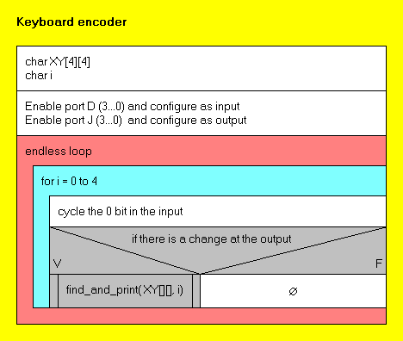
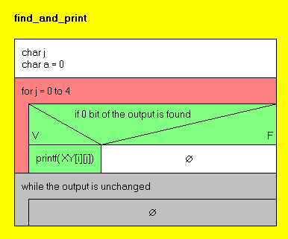

Question 3 (3 points)
Write the source code in C (shall be syntax error free (tested!), further tests with real-time constraints can be done in the lab session):
#include "lm3s9b92.h"
#include <stdio.h>

void find_and_print(char[4][4], char);

int main(){

char XY [4][4] = { {'1', '2', '3', 'F'},
{'4', '5', '6', 'E'},
{'7', '8', '9', 'D'},
{'A', '0', 'B', 'C'}};
char i;

SYSCTL_RCGC2_R = (1<<3) | (1<<8);
i = 0;

GPIO_PORTD_DEN_R |= 0x0F; // PD (3:0) enabled
GPIO_PORTD_DIR_R |= 0x0F; // PD (3:0) output

GPIO_PORTJ_DEN_R |= 0x0F; // PJ (3:0) enabled
GPIO_PORTJ_DIR_R &= 0x00; // PJ (3:0) input

while(1){
for(i=0; i<4; i++){
GPIO_PORTD_DATA_R = 0x0F; //initial value for input 1111
GPIO_PORTD_DATA_R &= ~(1 << i); //put a 0 at position i
if(GPIO_PORTJ_DATA_R != 0x0F){ //if there is a change in the output
find_and_print(XY, i); //call the function
}
}
}
}
void find_and_print(char XY[4][4], char i){
char j, a = 0;
for(j=0; j<4; j++){
if(GPIO_PORTJ_DATA_R % 2 == 0){ //finding the 0s at the output (if more than 1 button in the same collumn is pressed)
printf("%c", XY[i][j]); //print the char(s)
a |= 1 << j; //set 1 at the position(s) where is 0 at the output
}
GPIO_PORTJ_DATA_R /= 2;
}
while((GPIO_PORTJ_DATA_R & a) == 0){//until the button is pressed the value is 0
}//once the button is released the value will be different from 0 and the loop will break
}

